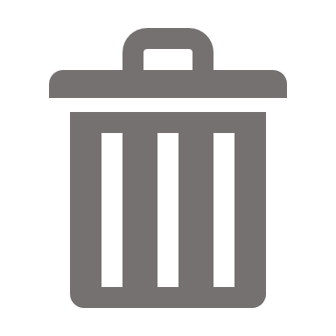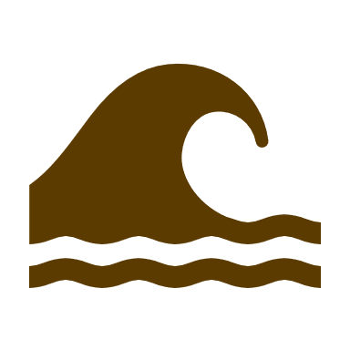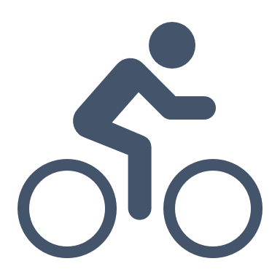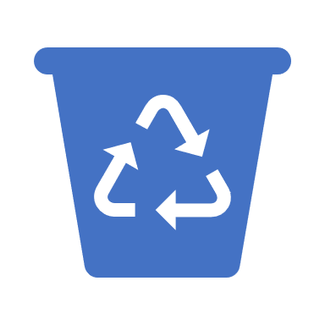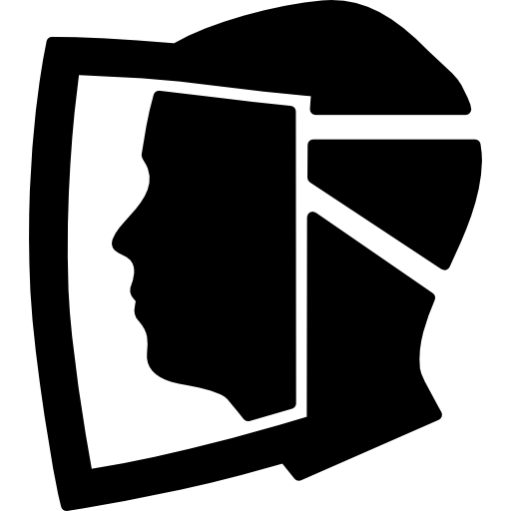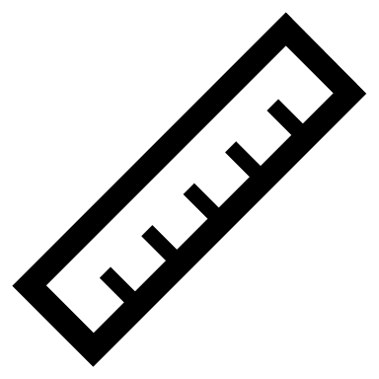

At the factory, the plastics that are received from the collection point and gathered from the bike are processed into a form where they can be reused. The plastic is shredded down into small flakes and sorted into different boxes depending on the flake sizes. The flakes are then used to create various items. These can be created by using either an injection machine, which injects melted plastics into a mould to create small objects, or by using an extrusion machine, which creates a line of plastic which can be spun into new items.

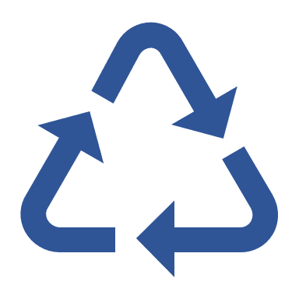

It is then taken to a local collection point. Here, the plastics are inspected and sorted into the various plastic types. A mobile collection bike can also be used to take the plastic to the recycling centre.

Waste is collected from three key areas:

* The town
* The local dumpsite
* The sea

He plastic can also be Imported from other areas of Peru if the supply was too low from the local area.

The recycled plastics will be used to make various items, such as face masks, key chains, and rules. Some items will benefit the locals in the area, other items will be sold to tourists to generate an income. Any additional income after expenses is then put back into the local area to help Lobitos.